**GIT Installation**

Right click on the ‘Git-2.20.0-64-bit.exe’ file and select ‘Run as administrator’ option.

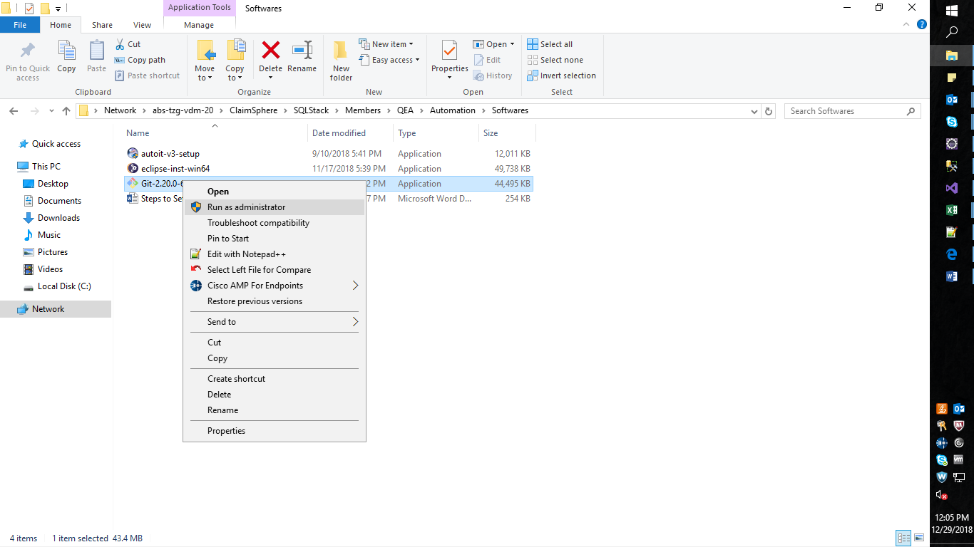

Click on the ‘Run’ button.

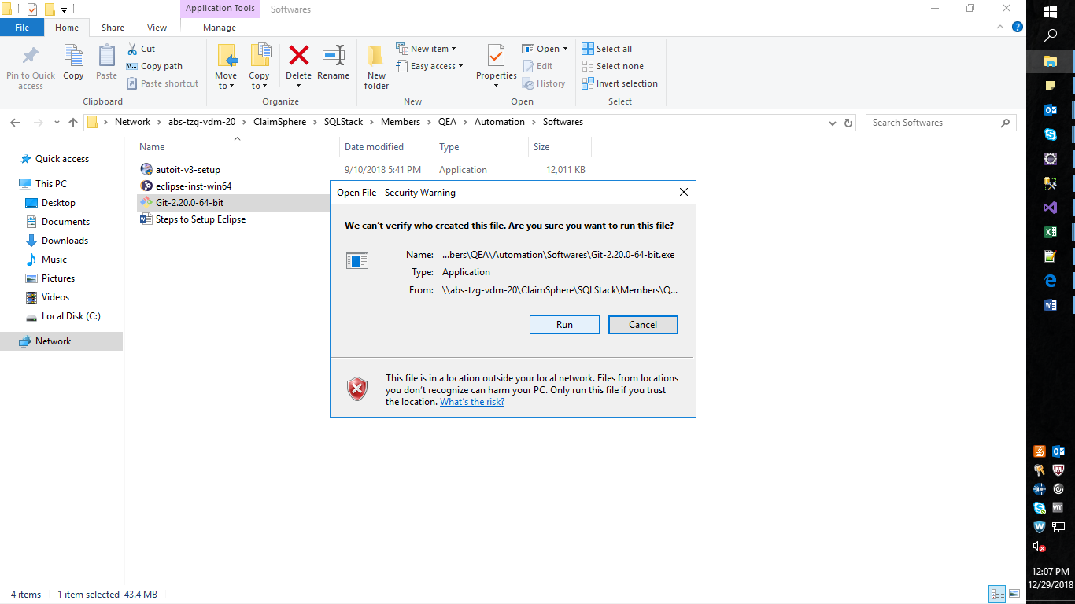

Click on the ‘Yes’ button.

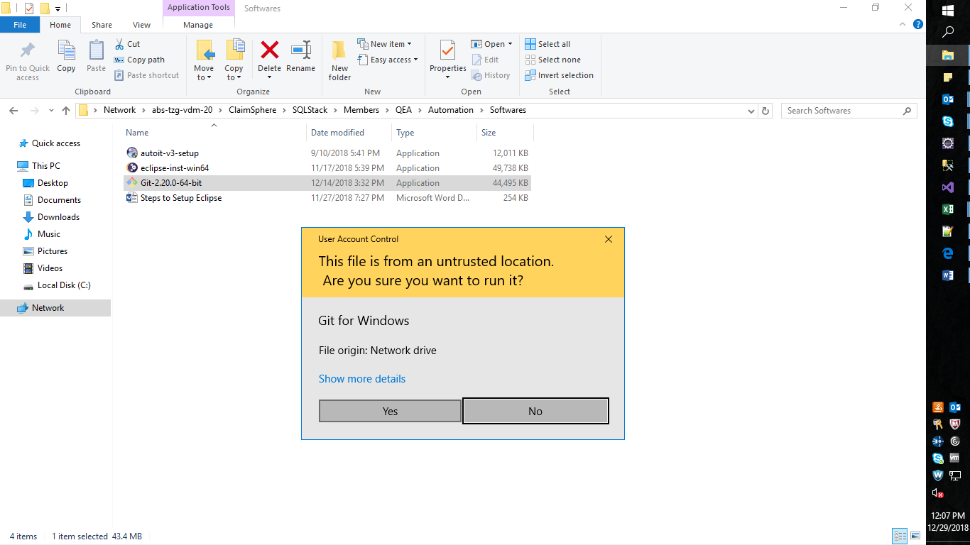

Click on the ‘Next’ button.

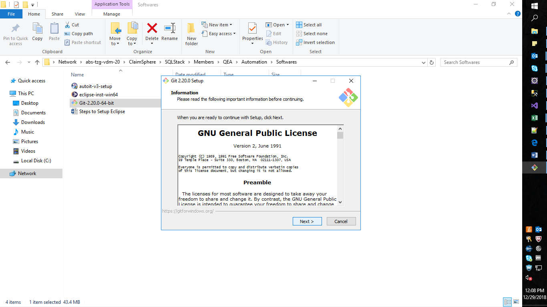

Click on the ‘Next’ button.

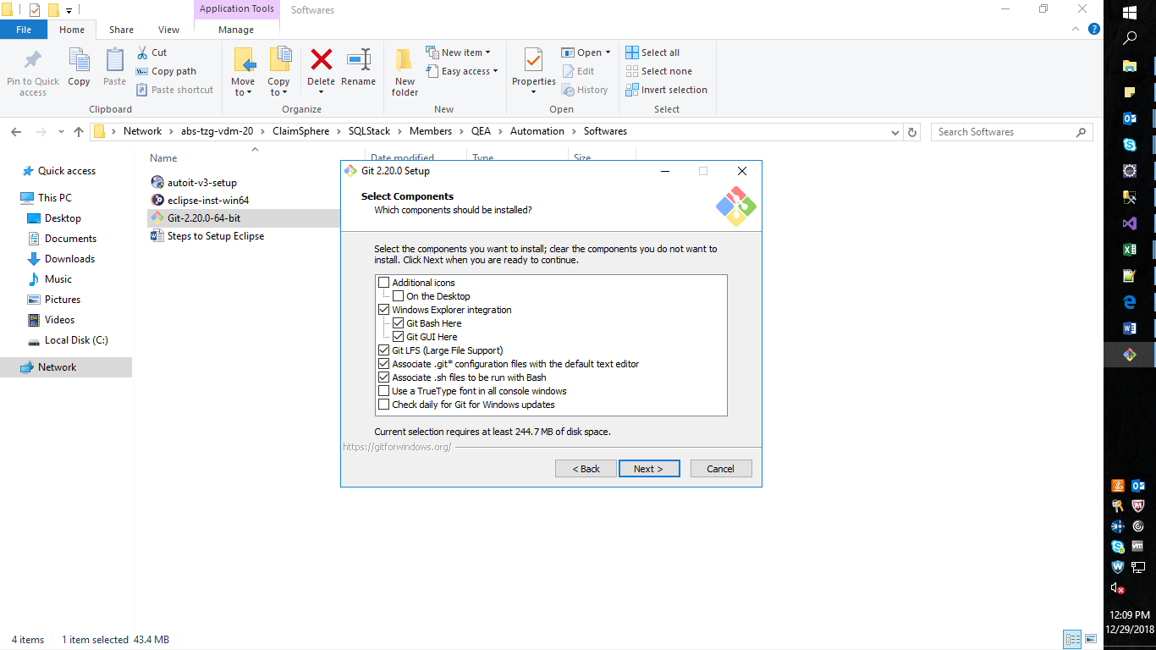

Click on the ‘Next’ button.

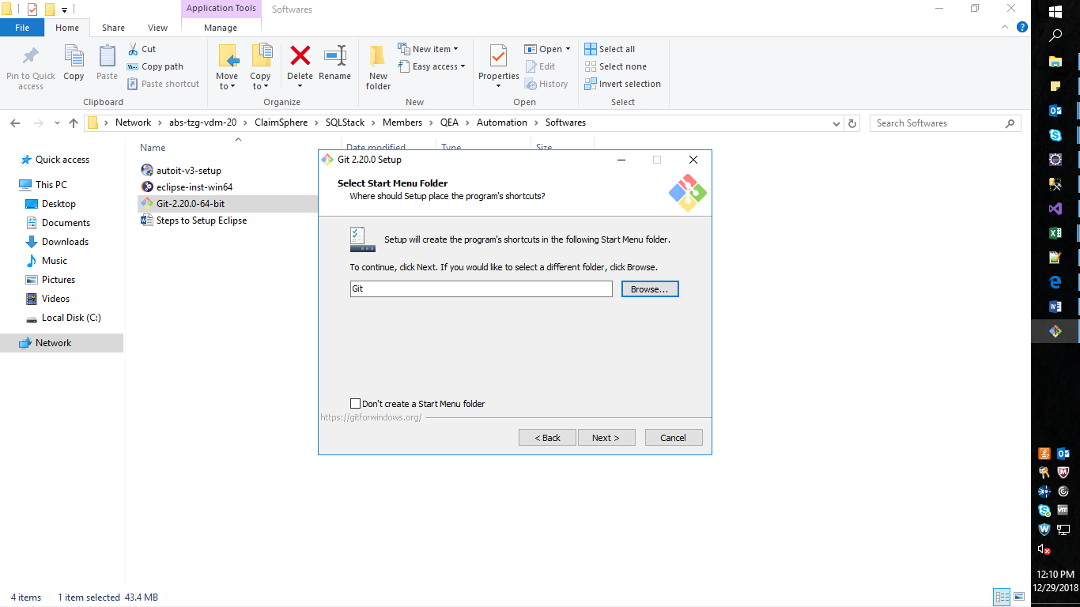

Select the option ‘Use the Nano editor by default’ from the dropdown and then click ‘Next’ button.

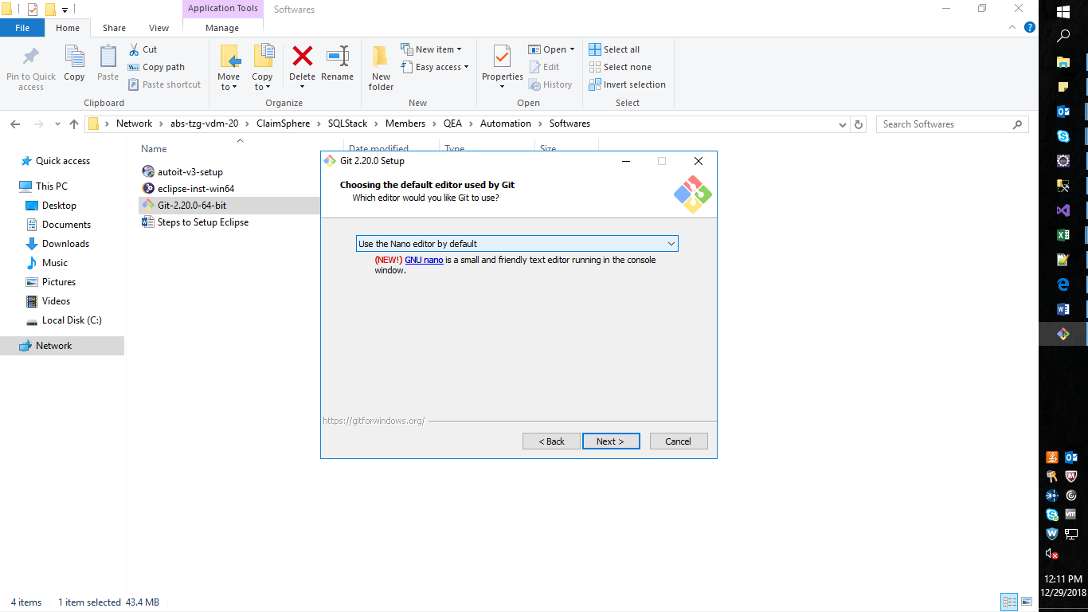

Select ‘Use Git from Git Bash only’ and then Click on the ‘Next’ button.

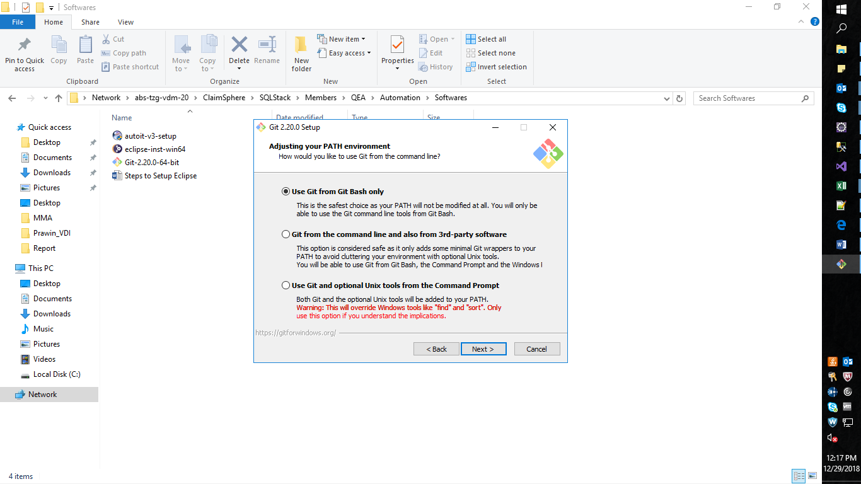

Click on the ‘Next’ button.

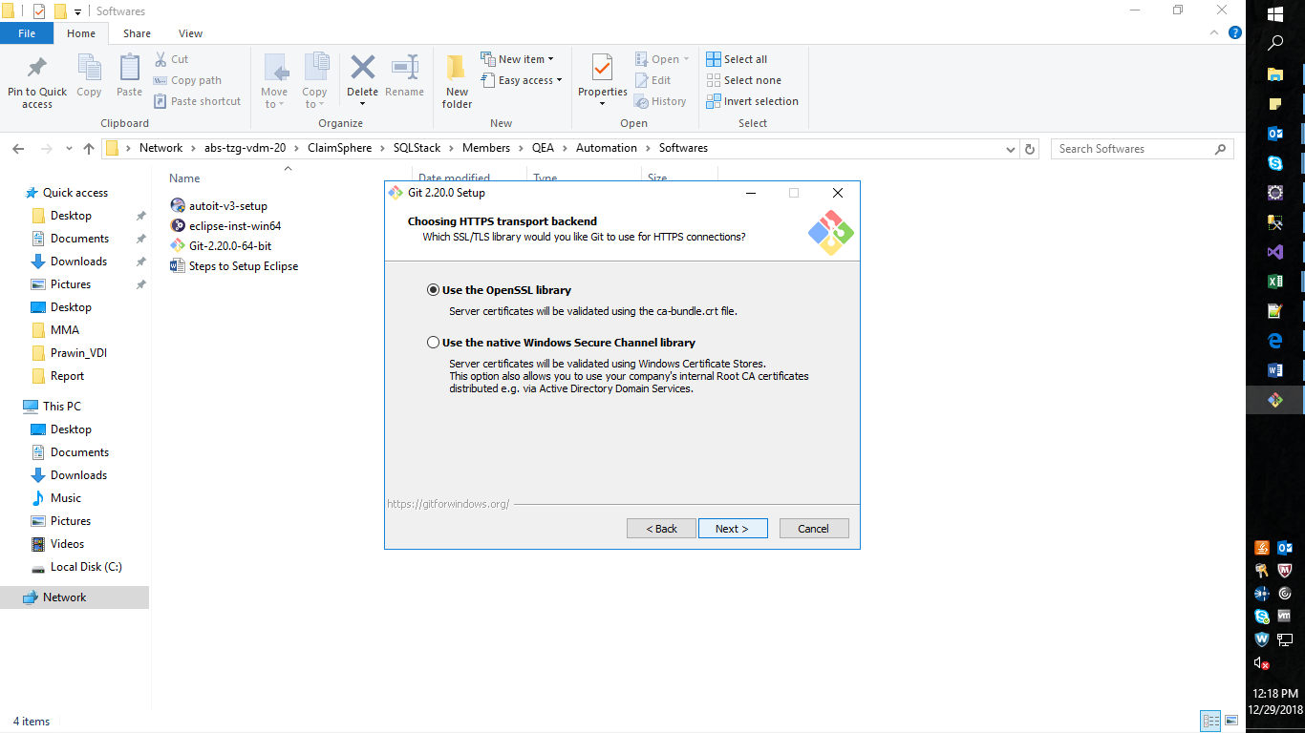

Click on the ‘Next’ button.

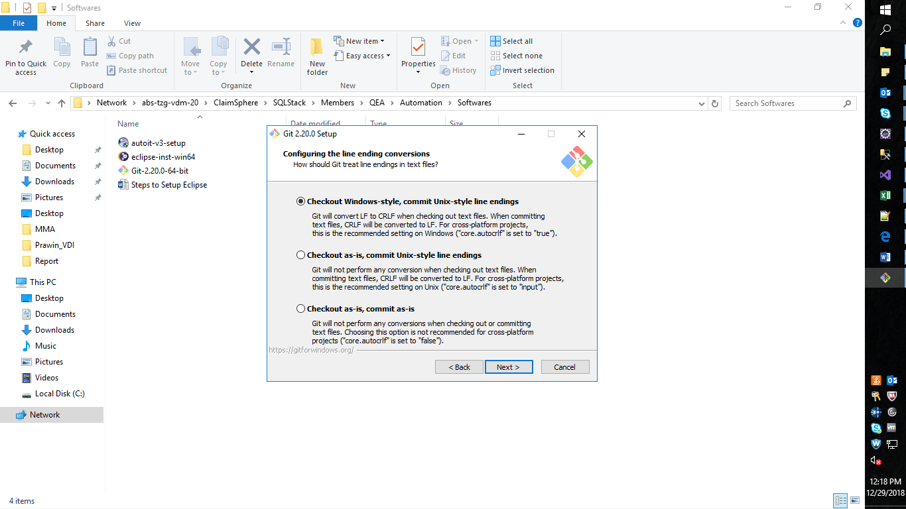

Click on the ‘Next’ button.

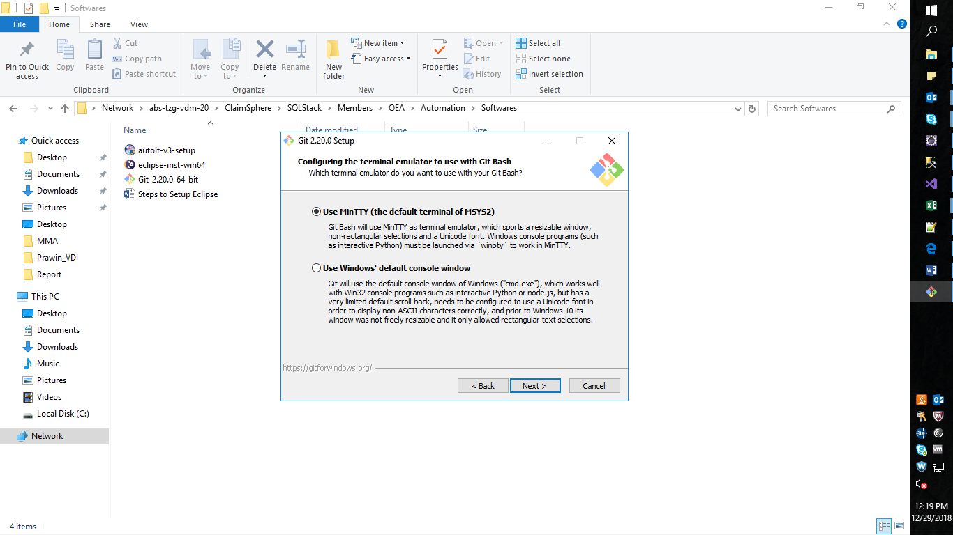

Check ‘Enable symbolic links’ also and click on the ‘Install’ button.

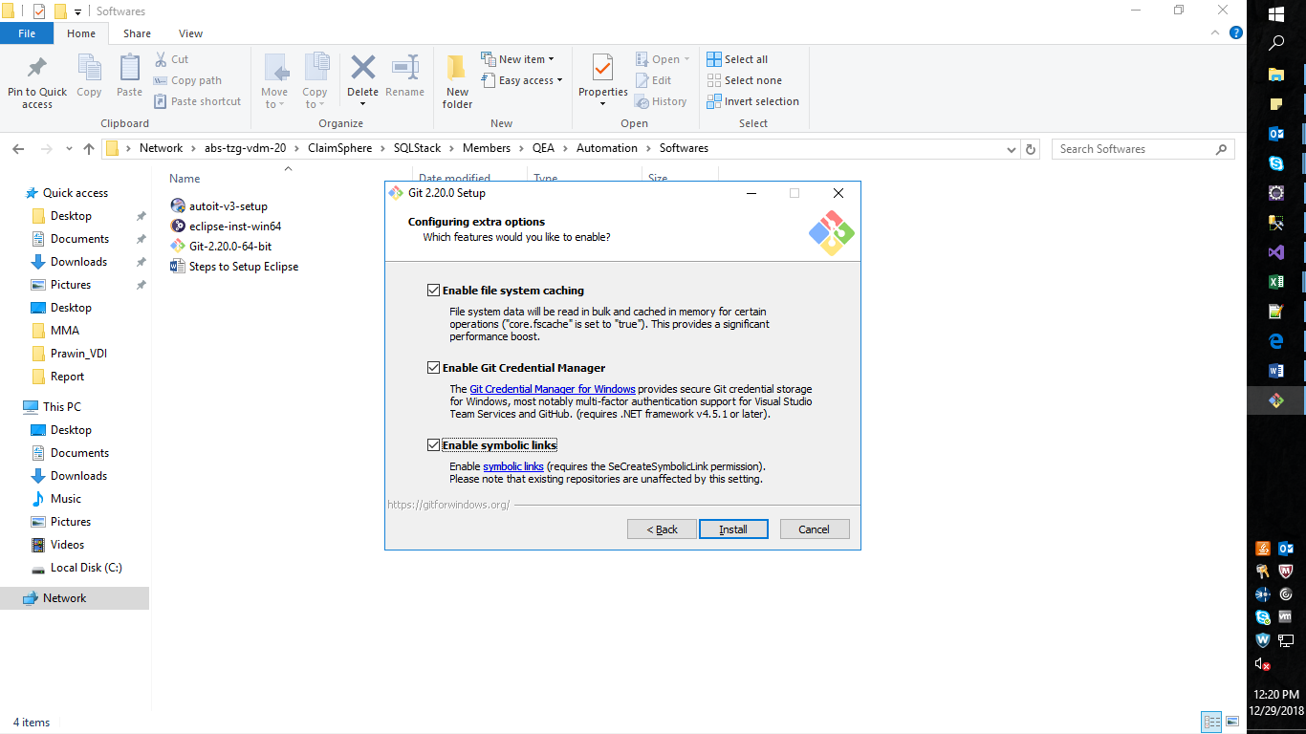

Installation will be initiated.

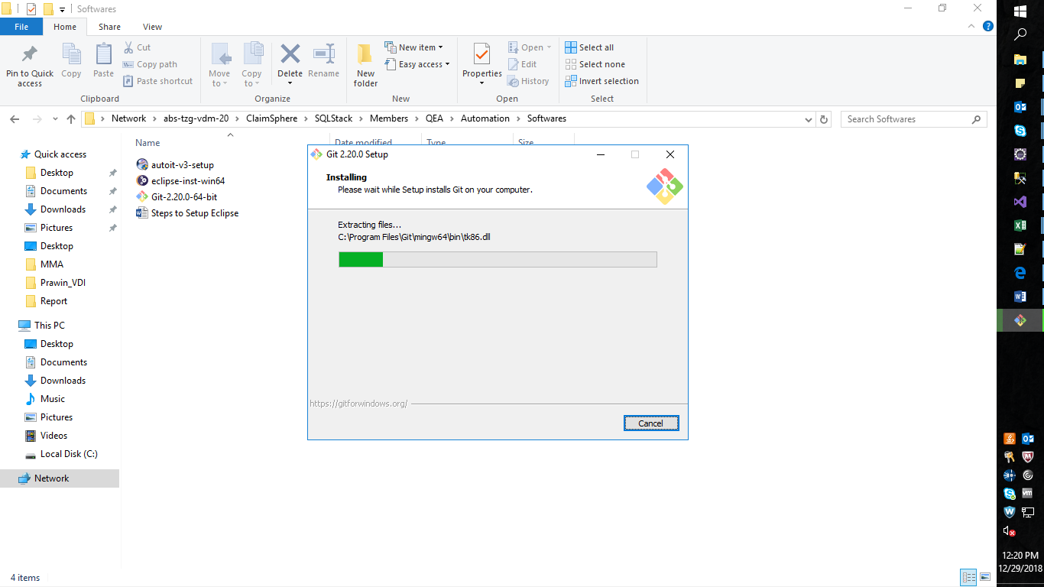

Uncheck both the checkboxes and click on the ‘Finish’ button.

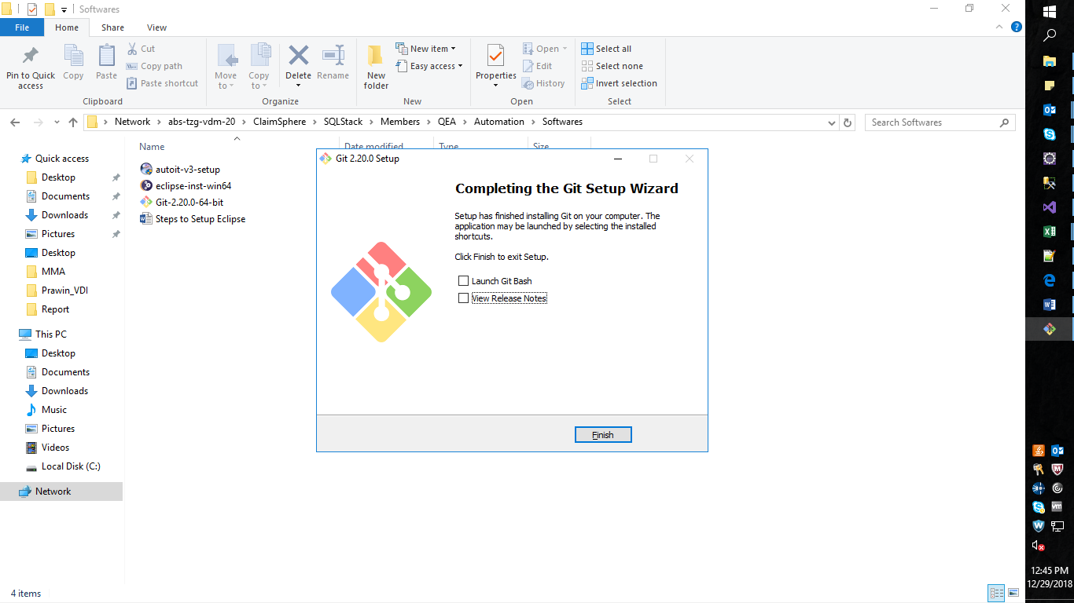

Verify the installation from start menu.



**Project importing (First time)**

**Create Work Space in Eclipse**

From the Eclipse select “File -> Switch Workspace -> Other”

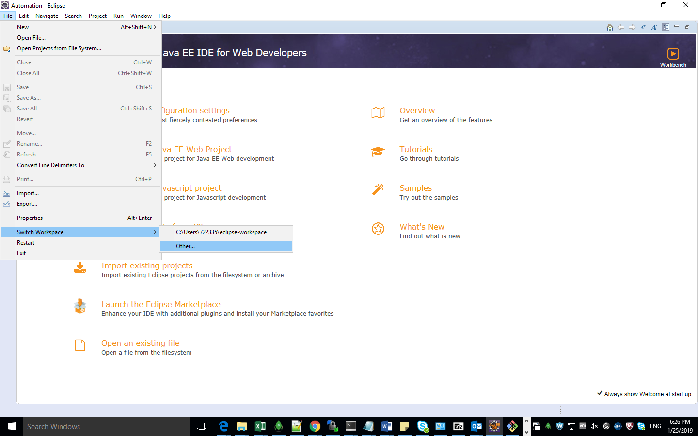

Click on the ‘Browse’ button.

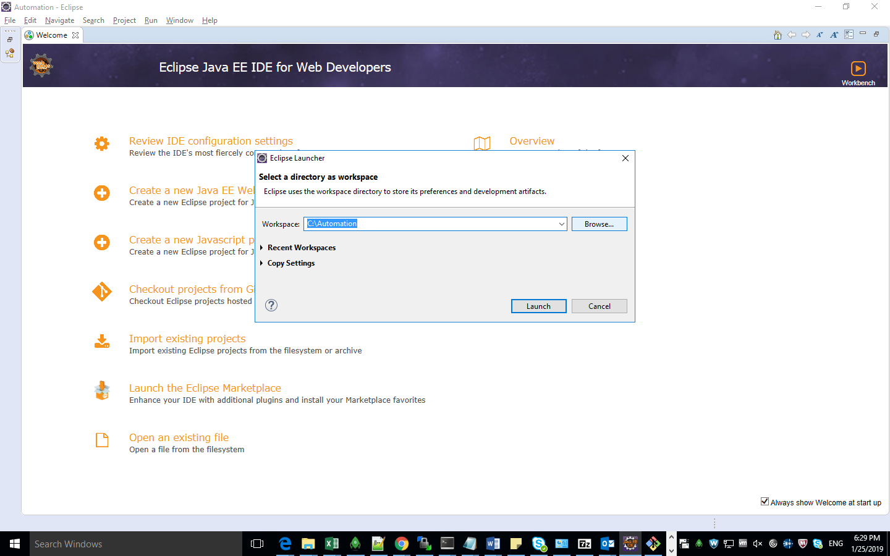

Create a new folder and select it and click on the ‘Select Folder’

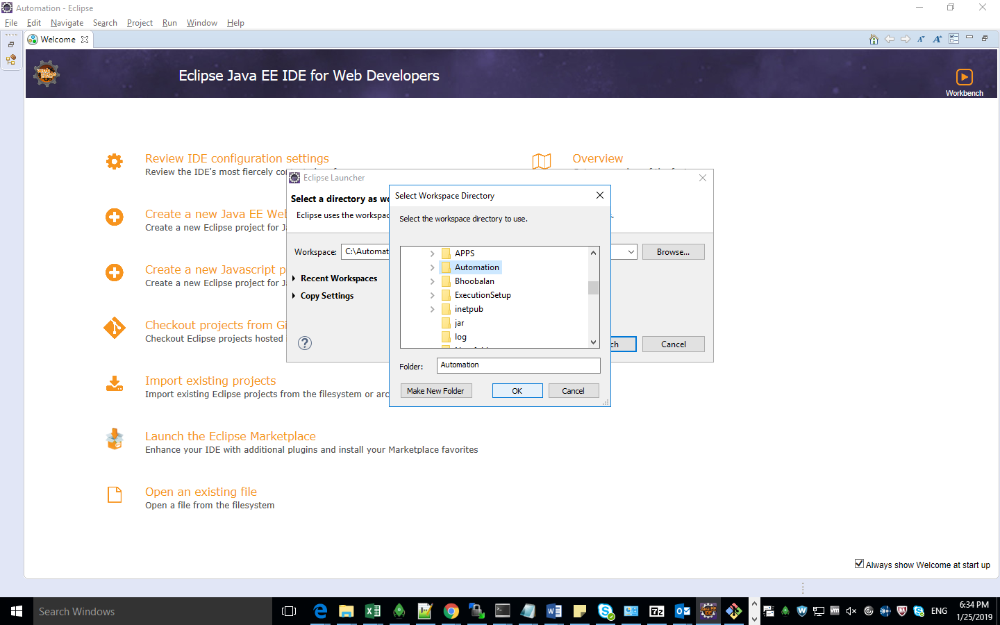

Click on the ‘Launch’ button.

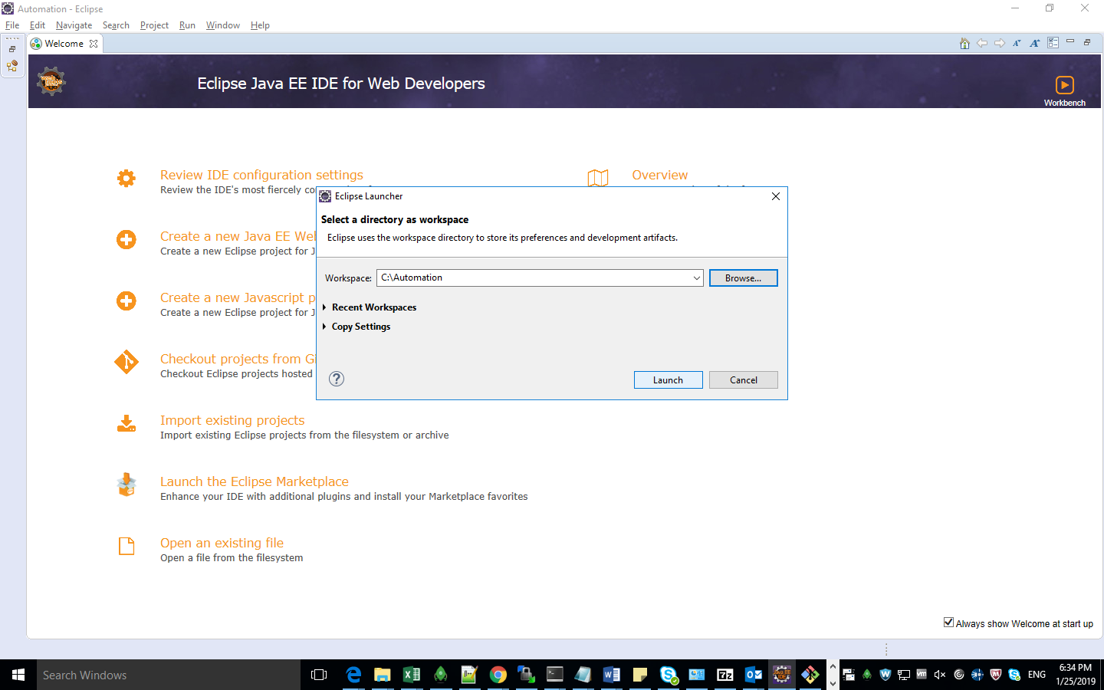

Navigate to the new folder created as workspace.

Right click inside the folder and select ‘Git Bash here’ option.

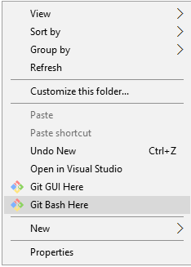

Copy this URL <https://pdstfs.trizetto.com/tfs/ClaimSphere/TestAutomation/_git/AutomationFramework>

Folders to be cloned from git.

‘AutomationFramework’ and ‘QaasAutomation’

**Code – Clone (First time)**

1. Enter the command “git clone <above copied path>” and press Enter.

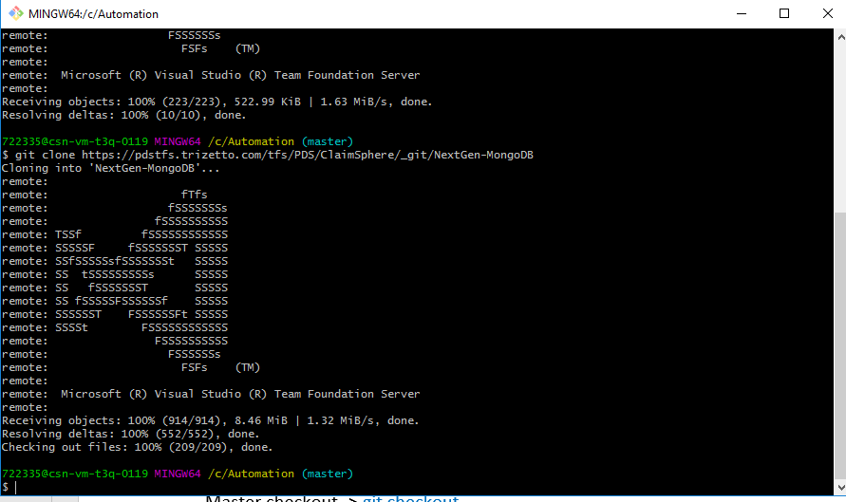

1. Once done, type the command “cd AutomationFramework” and press Enter.
2. Now type the command “git checkout feat/v13” and Enter.
3. Now type the command “cd ..” and press Enter.
4. Repeat all the above 4 steps for the below URL also

URL: <https://pdstfs.trizetto.com/tfs/ClaimSphere/TestAutomation/_git/QaaSAutomation>

1. Then enter “exit” and press Enter.

Ensure that all the required projects are cloned to the new workspace created in local machine.

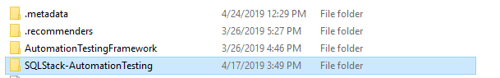

From Eclipse ‘File -> Import’

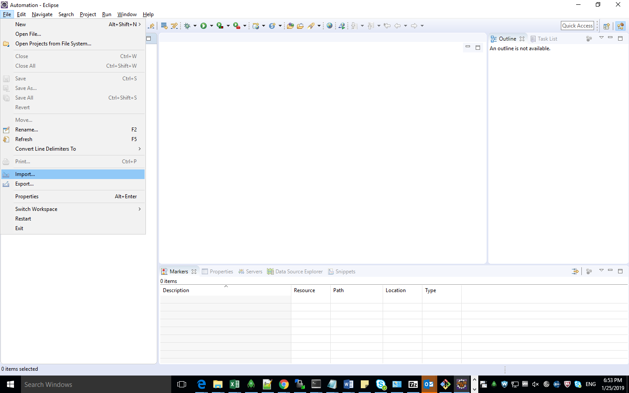

Expand ‘Maven’ and select ‘Existing Maven Project’ then click ‘Next’ button.

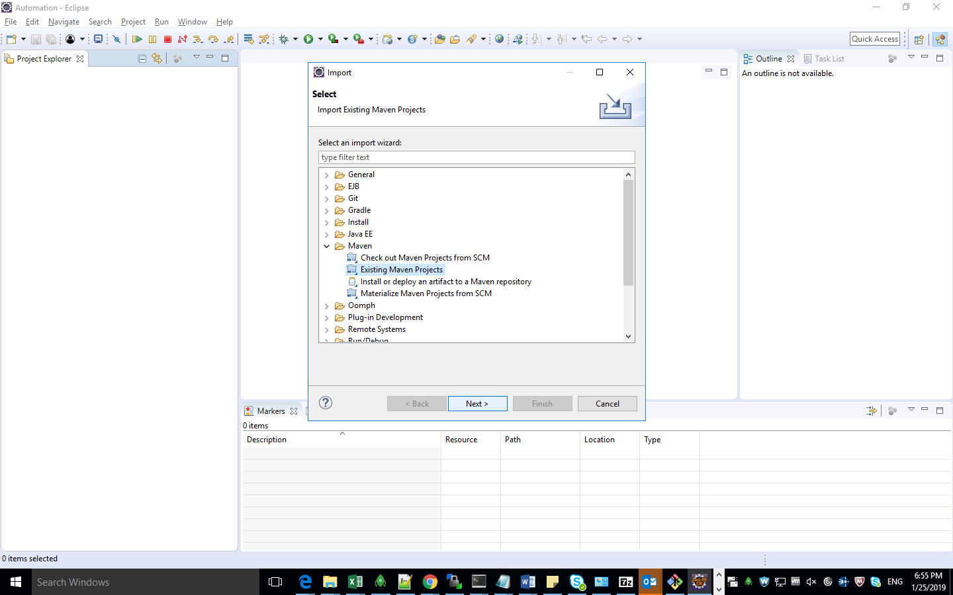

Click on the ‘Browse’ button.

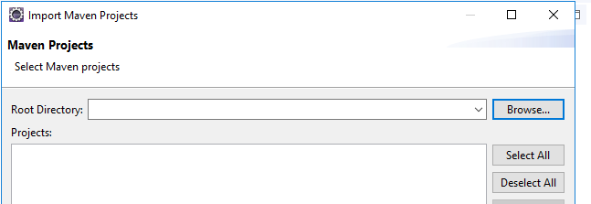

Navigate and select the project folder and click on the ‘OK’ button.

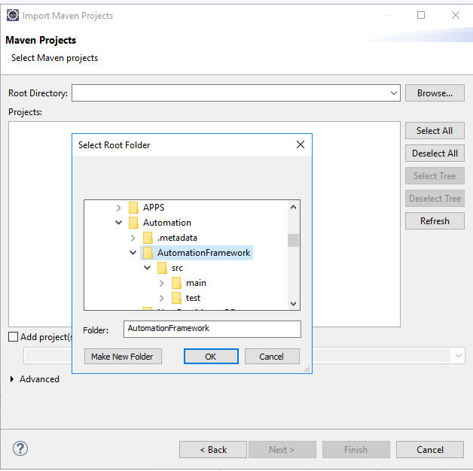

The pom.xml file will be select and displayed.

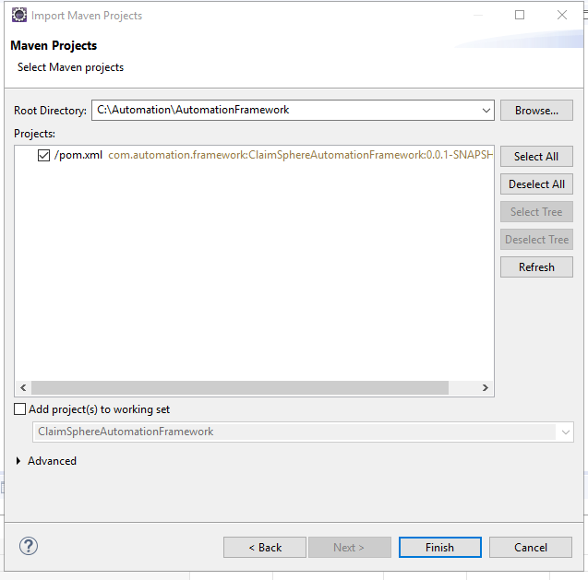

Just click on the ‘Finish’ button.

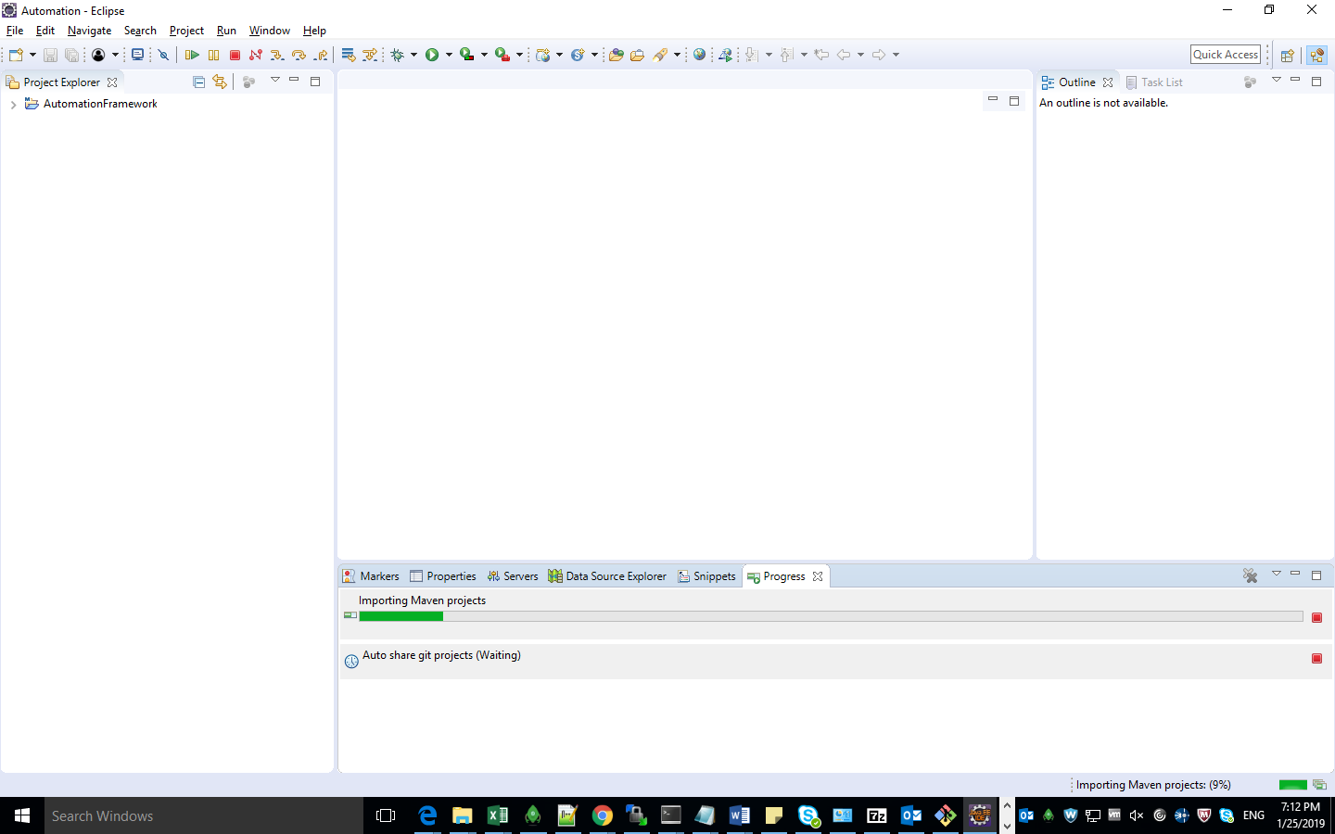

Wait for the status bar for at the bottom to load till 100% and display

“No operations to display at this time.” (Do the same for other project folders as well)

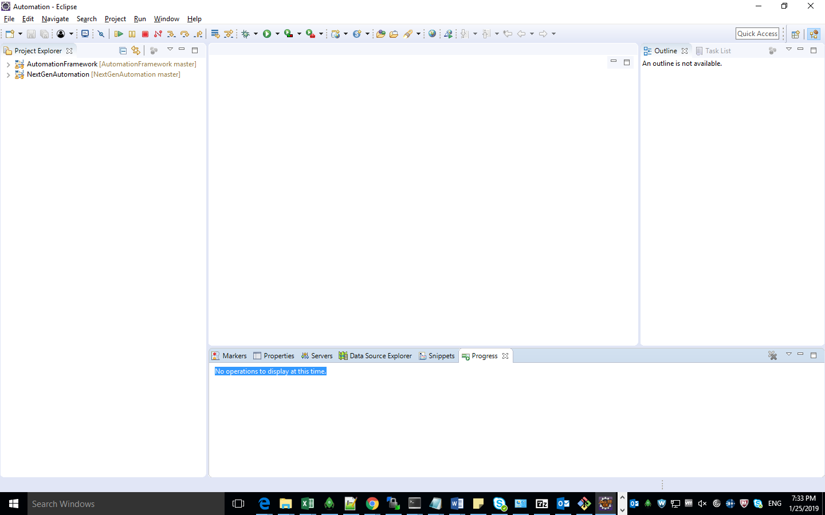

Expand the ‘AutomationFramework’ project and navigate to the ‘sqljdbc4-unsigned-2.0.jar’ file location.

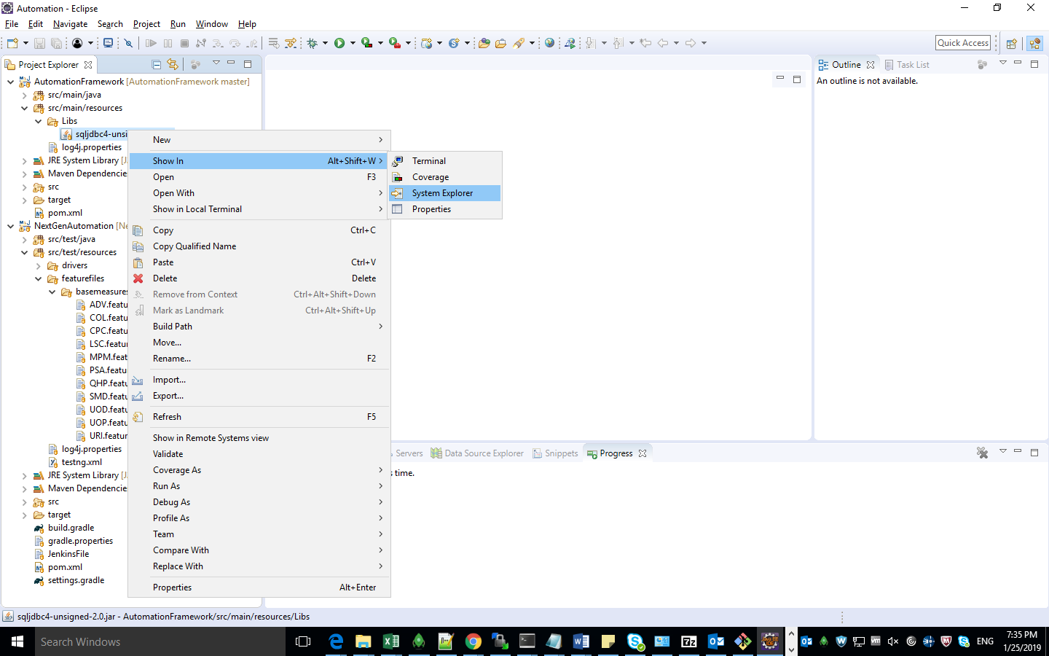

Copy the folder path.

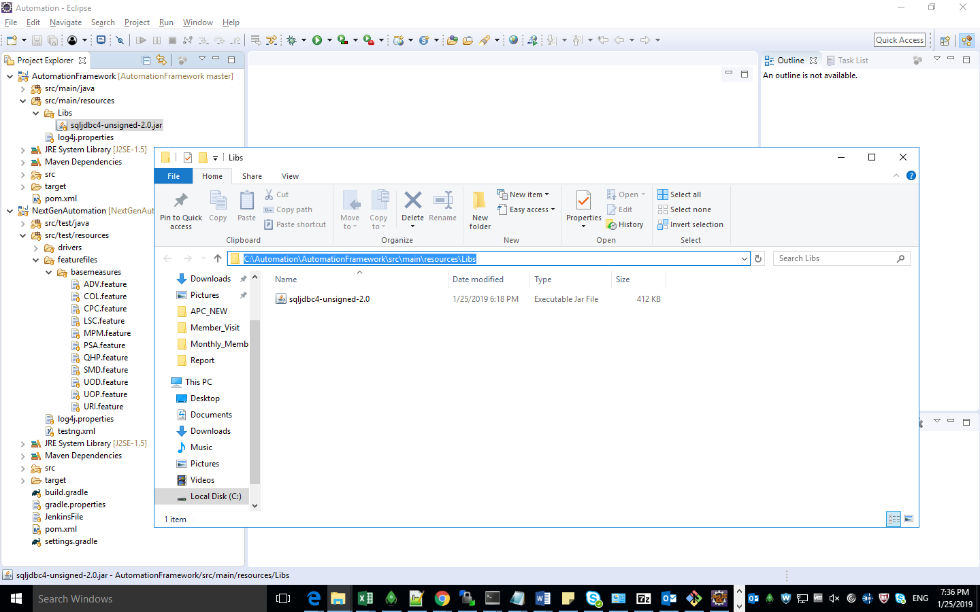

Right click on the ‘AutomationFramework’ project folder and select ‘Build path -> Configure Build path’

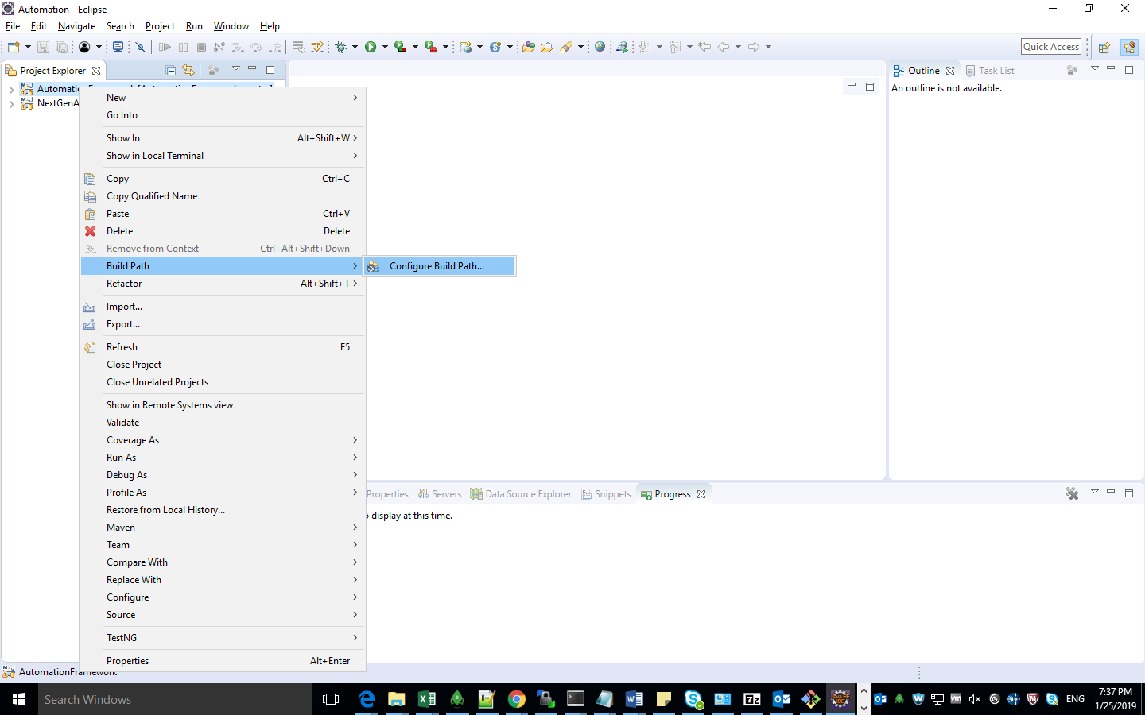

Select ‘Libraries’ tab.

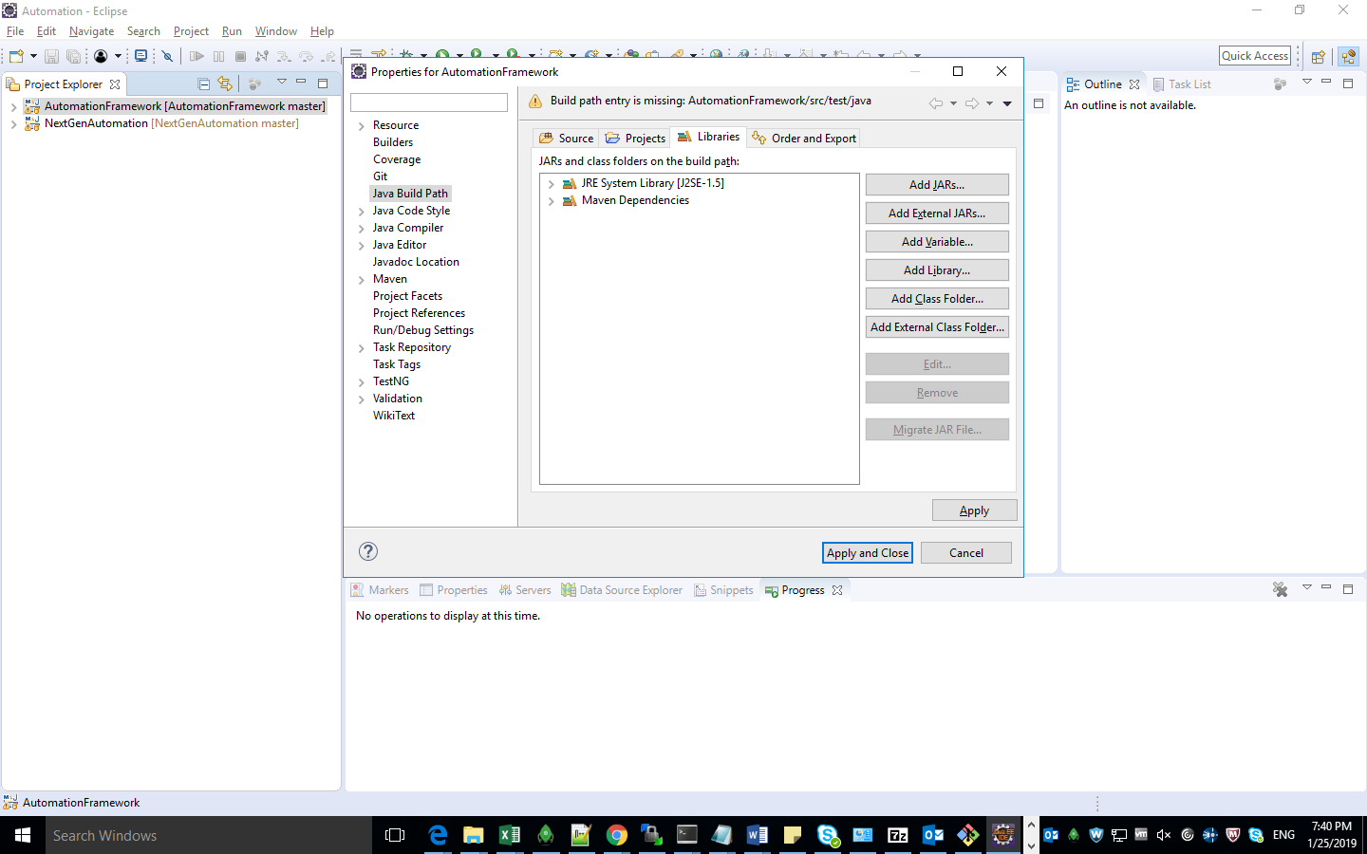

Select ‘Add External JARs’ button.

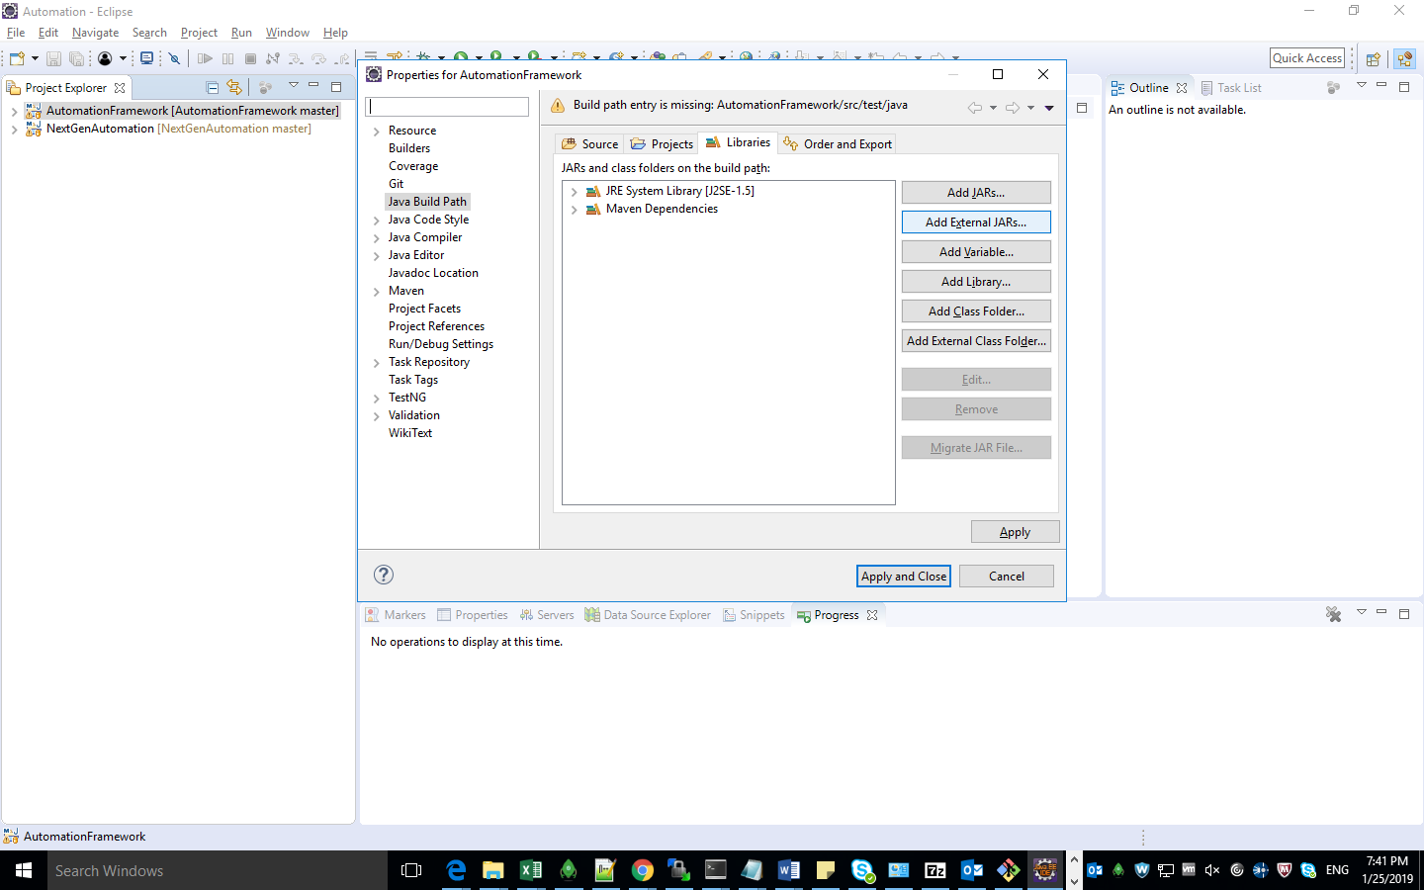

Paste the path in select the jar file and click on the ‘Open’ button.

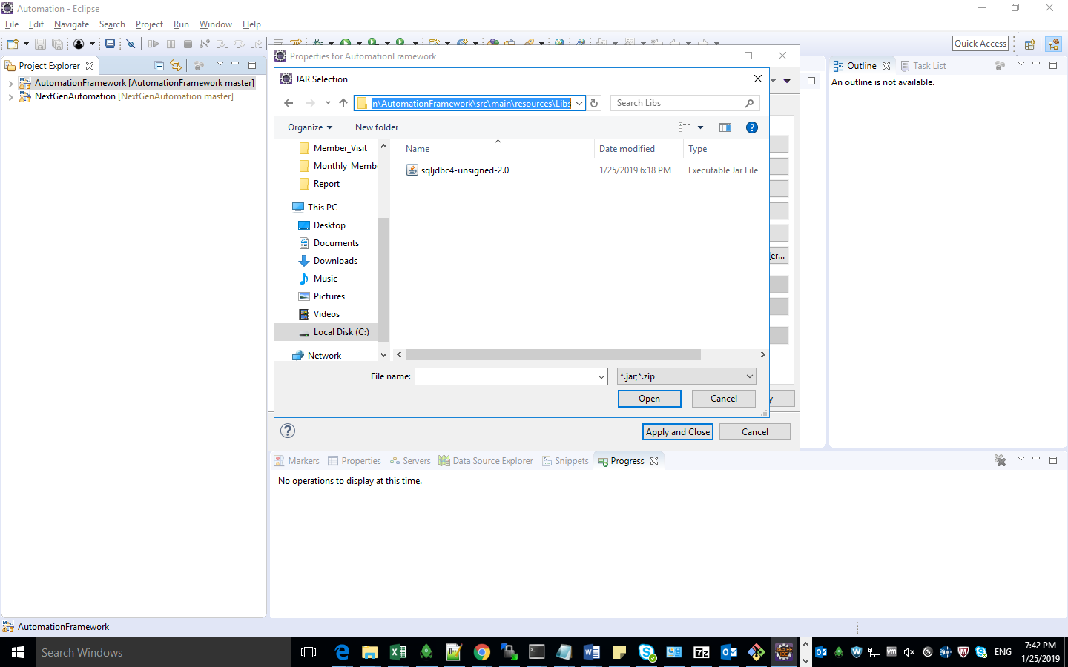

JAR file will be added to the libraries tab then click on the ‘Apply and Close’ button.

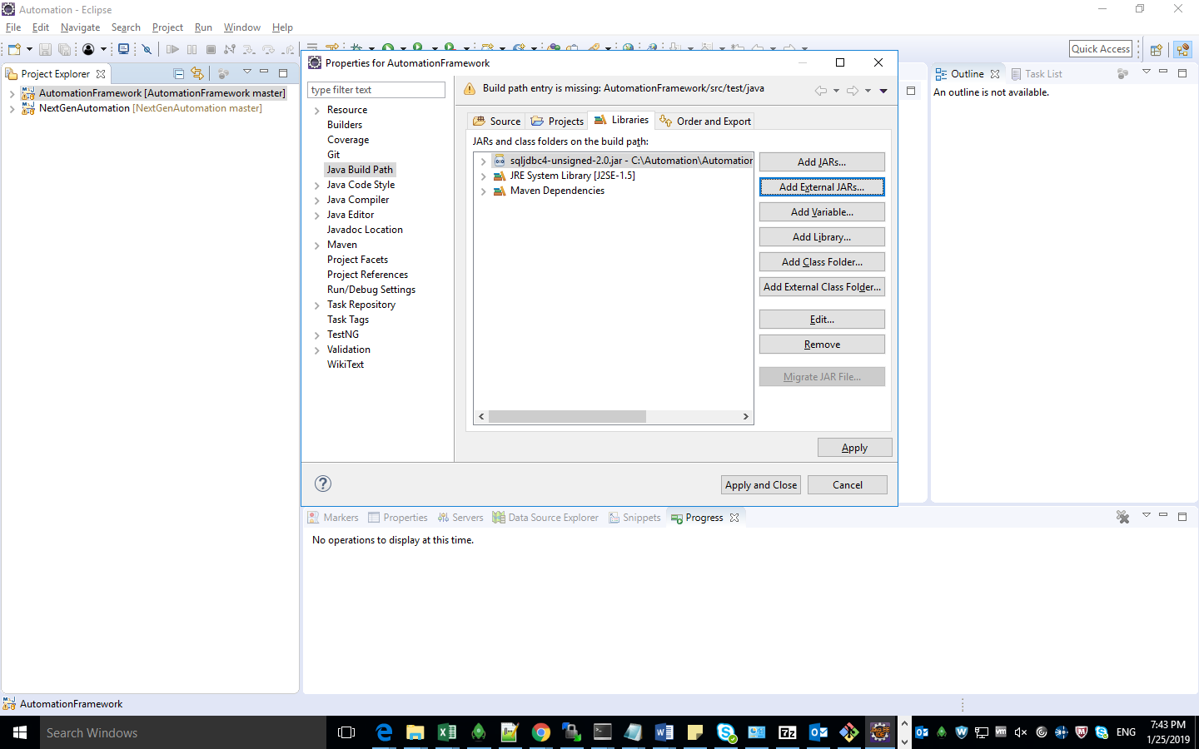

Wait for the status bar for at the bottom to load till 100% and display

“No operations to display at this time.”

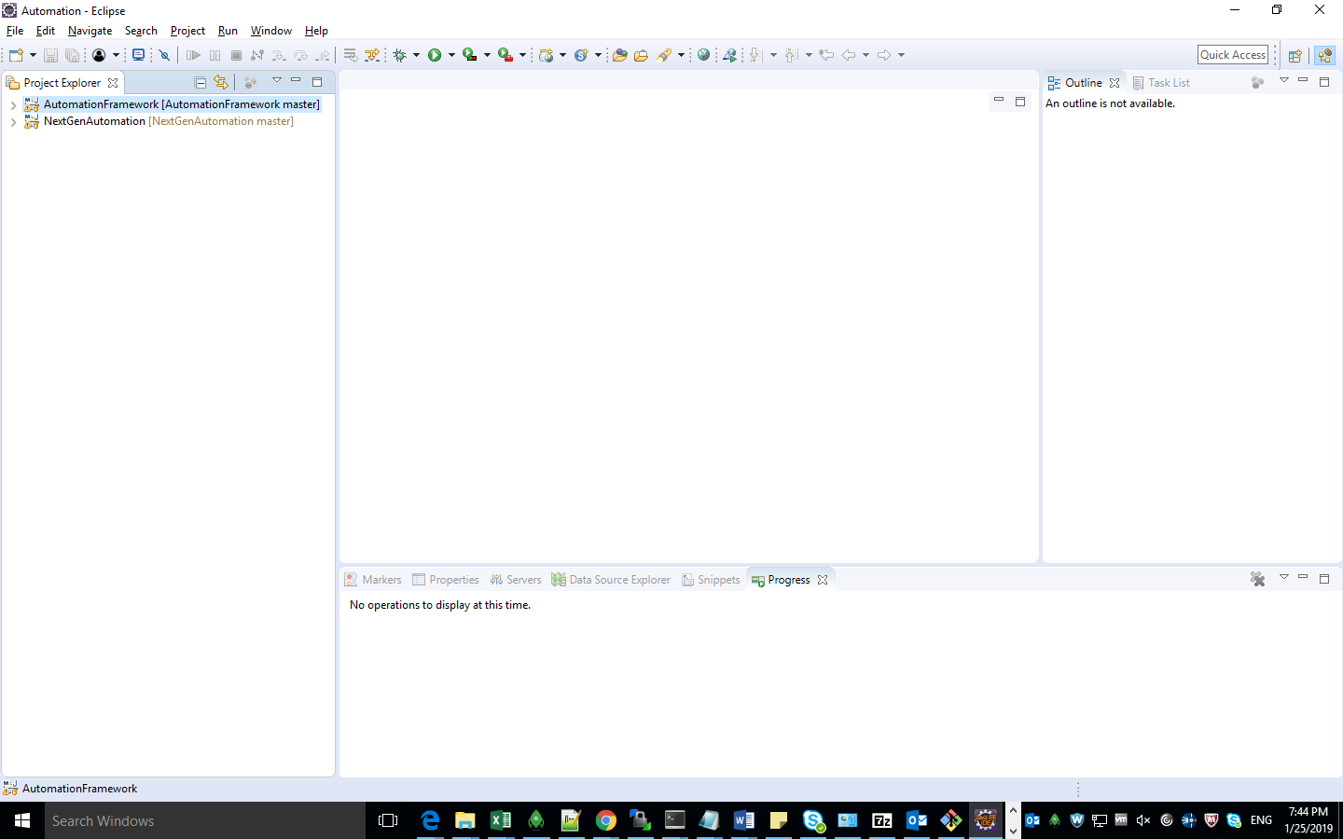

Copy the ‘Config.properties’ file from the below path.

Path: \\abs-tzg-vdm-20\ClaimSphere\SQLStack\Members\QEA\Automation\ConfigFile\MRR_Config

Place the ‘Config.properties’ file inside the project folder

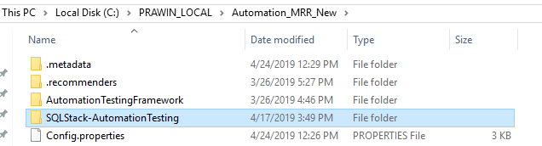

Copy the folder path/

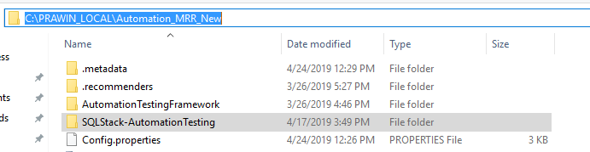

Right click on the ‘testng.xml’ file under the ‘SQLStack-AutomationTesting’ project folder in Eclipse.

And select ‘Run As -> TestNG Suite’ option.

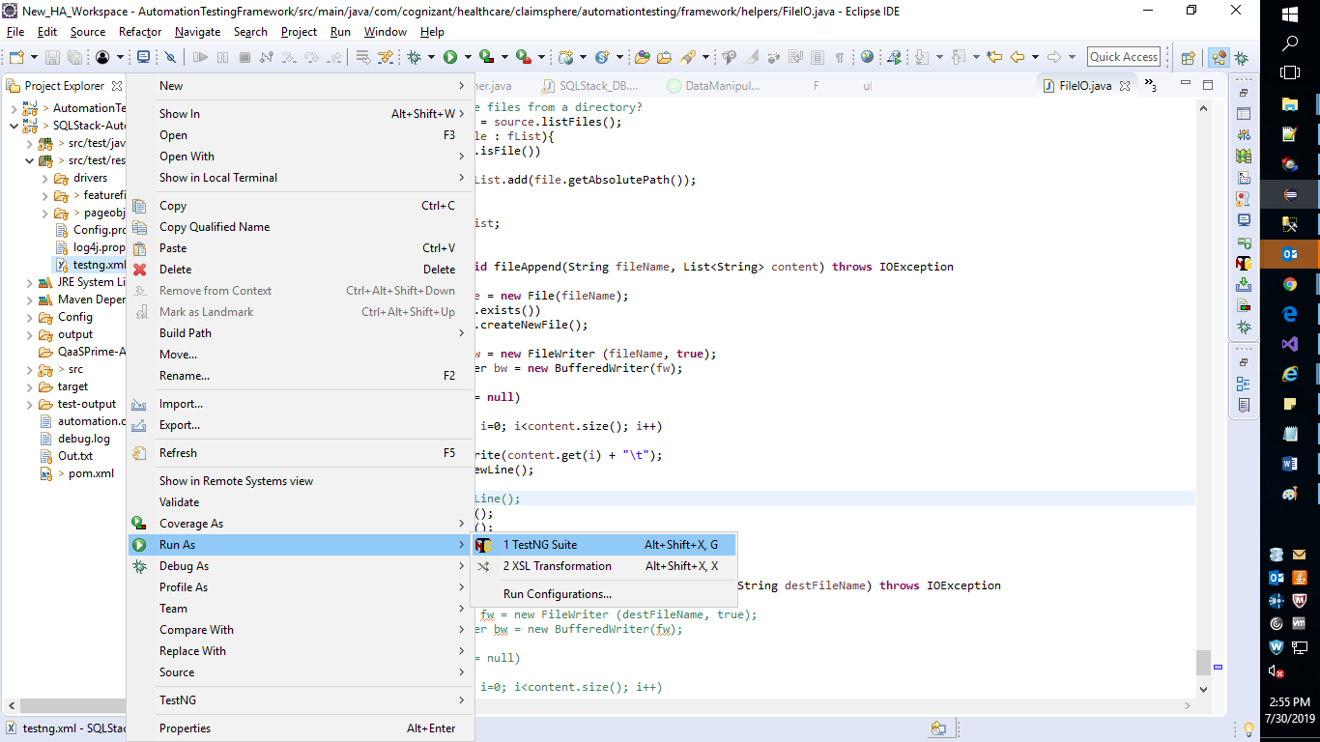

You will get the following message on the console screen.

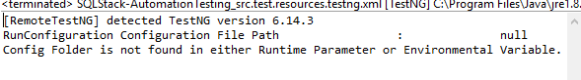

Right click on the ‘testng.xml’ file under the ‘SQLStack-AutomationTesting’ project folder in Eclipse.

And select ‘Run As -> Run Configurations…’ option.

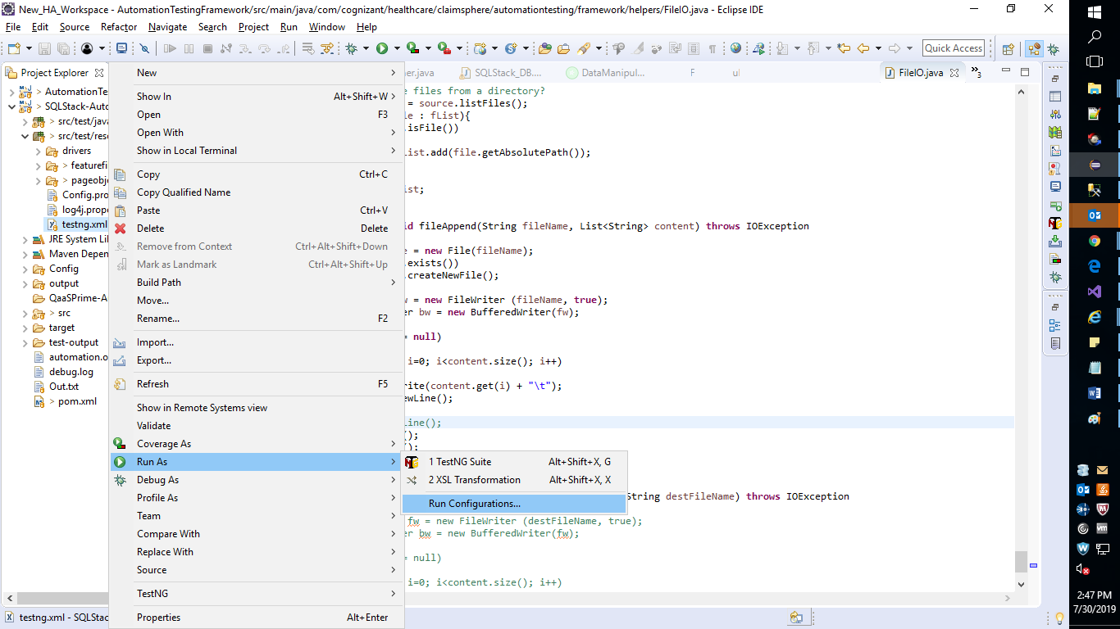

In the ‘Run Configuration’ pop up select ‘SQLStack-AutomationTesting…’ under ‘TestNG’

And enter “-DtestAutomation.Config=” followed by the project path copied earlier.

Then Click on ‘Apply’ button.

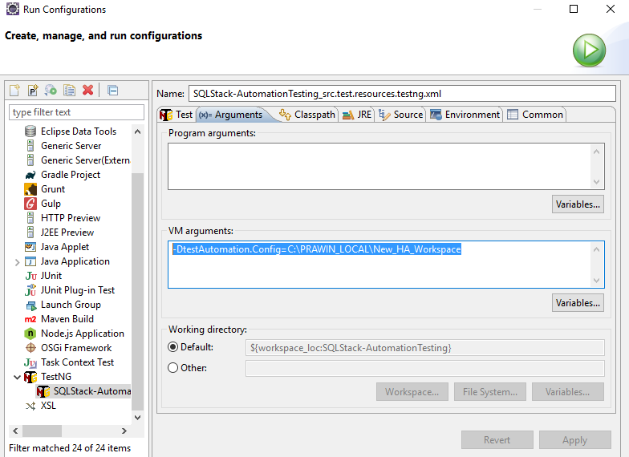

**Reference Doc**

Please refer the ‘Git - An overview.ppt’ attached here for more details.

